**Splunk: Data Manipulation**

Task 1

Data processing, parsing, and manipulation in Splunk are crucial for extracting meaningful insights and enabling effective analysis of machine-generated data. From a security perspective, these capabilities are particularly valuable in identifying and responding to security threats, investigating incidents, and monitoring system health.

**Learning Objective**

Some of the learning objectives that this room will cover are:

* How Events are parsed in Splunk
* Importance of configuration files like inputs.conf, transform.conf, and props.conf
* How to Extract custom fields and apply them to filter
* How to identify the timestamp in the Event logs

**Prerequisites**

This room expects users to have completed the following rooms:

* [Regex](https://tryhackme.com/room/catregex) --Done
* [Splunk Basics](https://tryhackme.com/room/splunk101) –Done

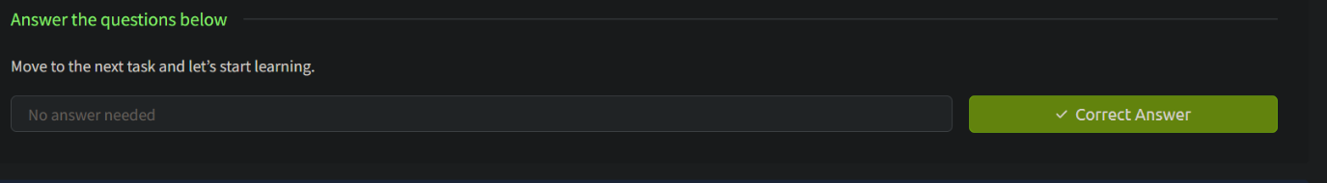

Task 2 Scenario and Lab Instructions

Start the Machine

Let’s play a scenario where You are John, who is working as a SOC Analyst at CyberT. You have been presented with a scenario where one of our clients needs to ingest some logs from a custom source.

Splunk needs to be properly configured to parse and transform the logs appropriately. Some of the issues being highlighted are:

* **Event Breaking:**
  + Configure Splunk to break the events properly.
* **Multi-line Events:**
  + Configure Splunk to configure multi-line events properly.
* **Masking:**
  + Some logs contain sensitive data. To comply with the PCI DSS (Payment Card Industry Data Security Standard) standard, information like credit card numbers must be masked to avoid any violation.
* **Extracting custom fields:**
  + In the weblogs, some fields are redundant and need to be removed.

Let’s connect to the lab and continue to understand how Splunk data manipulation works at the configuration level.

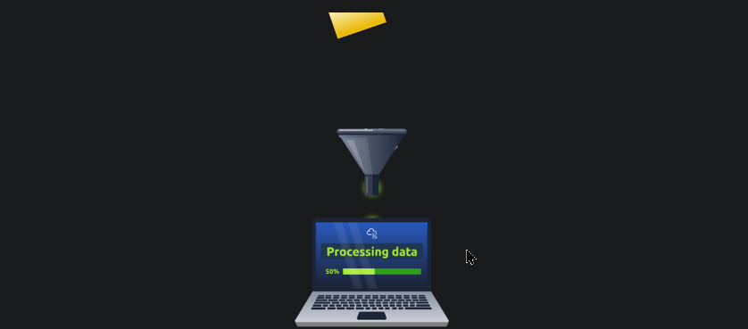

Room Machine

Before moving forward, start the lab by clicking the Start Machine button. The lab will be accessible via split screen. If the VM is not visible, use the blue Show Split View button at the top-right of the page. Once the VM is in split screen view, you can click the + button to show it on a full screen. The VM will take 3-5 minutes to load properly. In this room, we will be working using the terminal of the VM and accessing the Splunk instance at <ip>

**Note:** The scripts we will be working on are placed in the ~/Downloads/scripts directory. We will need to run all the commands with a root user.

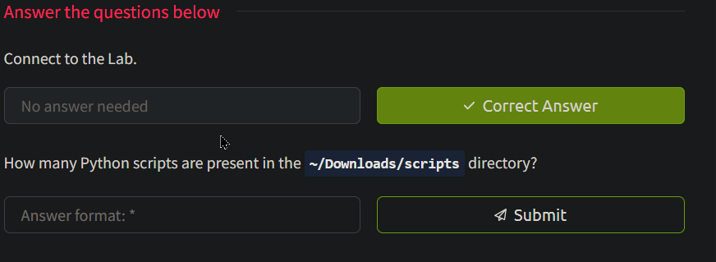

Answer: 3

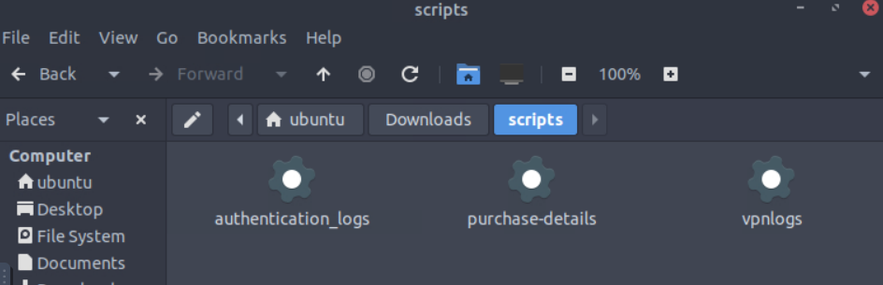

Task 3 Splunk Data Processing: Overview

Splunk is a powerful data analytics platform used for searching, monitoring, and analyzing large amounts of machine-generated data. Data parsing in Splunk involves extracting relevant fields and transforming the data into a structured format for efficient analysis. Here’s a step-by-step guide on how data is parsed in Splunk, including the use of props.conf:

Step 1: Understand the Data Format

First, you need to understand the data format you want to parse. Splunk supports various data formats, such as CSV, JSON, XML, syslog, and more. Determine the format of your data source and the relevant fields you want to extract.

Step 2: Identify the Sourcetype

In Splunk, the sourcetype represents the format of the data being indexed. It helps Splunk apply the appropriate parsing rules. If your data source does not have a pre-defined sourcetype, you can create a custom one in Splunk.

Step 3: Configure props.conf

The props.conf file defines data parsing settings for specific sourcetypes or data sources. It resides in the $SPLUNK_HOME/etc/system/local directory. Here’s an example of how you can configure props.conf:

[source::/path/to/your/data]

sourcetype = your_sourcetype

In this example, /path/to/your/data is the path to your data source, and your_sourcetype is the name of the sourcetype you want to assign to that data.

Step 4: Define Field Extractions

You can define regular expressions or use pre-built extraction techniques to parse fields from the data. Here’s an example of defining field extractions in props.conf:

[your_sourcetype]

EXTRACT-fieldname1 = regular_expression1

EXTRACT-fieldname2 = regular_expression2

Replace your_sourcetype with the actual sourcetype name you defined. fieldname1 and fieldname2 represent the names of the fields you want to extract, while regular_expression1 and regular_expression2 are the regular expressions used to match and extract the desired values.

Step 5: Save and Restart Splunk

After making changes to props.conf, save the file, and restart Splunk to apply the new configurations. You can do this using the Splunk web interface or by using the command line.

Step 6: Verify and Search the Data   
  
Once Splunk restarts, you can search and verify that the data is being parsed correctly. You can use the extracted fields to filter and analyze the data effectively.

In the next task, we will explore important configuration files.

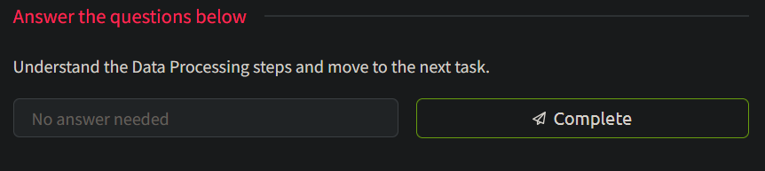

Task 4

Exploring Splunk Configuration files

Splunk uses several [configuration files](https://docs.splunk.com/Documentation/Splunk/9.1.1/Admin/Listofconfigurationfiles) to control various data processing and indexing aspects. Let’s explore some of the key configuration files in Splunk, along with examples of their usage:

inputs.conf:

* **Purpose:** Defines data inputs and how to collect data from different sources.
* **Example:** Suppose you want to monitor a specific log file. You can configure inputs.conf as follows:

[monitor:///path/to/logfile.log]

sourcetype = my_sourcetype

props.conf:

* **Purpose:** Specifies parsing rules for different sourcetypes to extract fields and define field extractions.
* **Example:** Suppose you have a custom sourcetype named my_sourcetype and want to extract fields using regular expressions. You can define them in props.conf:

[my_sourcetype] EXTRACT-field1 = regular_expression1

EXTRACT-field2 = regular_expression2

transforms.conf

* **Purpose:** Allows you to define field transformations and enrichments on indexed events.
* **Example:** Suppose you want to add a new event field based on existing field values. You can use transforms.conf:

[add_new_field] REGEX = existing_field=(.*) FORMAT = new_field::$1

indexes.conf

* **Purpose:** Manages the configuration of indexes in Splunk, including storage, retention policies, and access control.
* **Example:** Suppose you want to create a new index named my_index with specific settings. You can configure indexes.conf:

[my_index] homePath = $SPLUNK_DB/my_index/db

coldPath = $SPLUNK_DB/my_index/colddb

thawedPath = $SPLUNK_DB/my_index/thaweddb

maxTotalDataSizeMB = 100000

outputs.conf

* **Purpose:** Specifies the destination and settings for sending indexed data to various outputs, such as remote Splunk instances or third-party systems.
* **Example:** Suppose you want to forward your indexed data to a remote Splunk indexer. You can configure outputs.conf:

[tcpout] defaultGroup = my_indexers

[tcpout:my_indexers]

server = remote_indexer:9997

authentication.conf

* **Purpose:** Manages authentication settings and user authentication methods.
* **Example:** Suppose you want to enable LDAP authentication for Splunk users. You can configure authentication.conf:

[authentication]

authSettings = LDAP

[authenticationLDAP]

SSLEnabled = true

These are just a few examples of the various configuration files used in Splunk. Each file serves a specific purpose and allows you to customize Splunk’s behavior based on your data sources, parsing requirements, indexing settings, output destinations, and more.

**﻿STANZAS in Splunk Configurations**

Splunk configurations contain various stanza configurations that define how data is processed and indexed. These stanzas have a certain purpose, and it's important to understand what these are and how they are used. A brief summary of the common stanzas are explained below:

| **Stanza** | **Explanation** | **Example** |
| --- | --- | --- |
| [sourcetype] | Specifies the configuration for a specific sourcetype. It allows you to define how the data from that sourcetype should be parsed and indexed. | [apache:access] - Configures parsing and indexing settings for Apache access logs. |
| TRANSFORMS | Applies field transformations to extracted events. You can reference custom or pre-defined field transformation configurations to modify or create new fields based on the extracted data. | TRANSFORMS-mytransform = myfield1, myfield2 - Applies the transformation named “mytransform” to fields myfield1 and myfield2. |
| REPORT | Defines extraction rules for specific fields using regular expressions. It associates a field name with a regular expression pattern to extract desired values. This stanza helps in parsing and extracting structured fields from unstructured or semi-structured data. | REPORT-field1 = pattern1 - Extracts field1 using pattern1 regular expression. |
| EXTRACT | Defines extraction rules for fields using regular expressions and assigns them specific names. It is similar to the REPORT stanza, but it allows more flexibility in defining custom field extractions. | EXTRACT-field1 = (?<fieldname>pattern1) - Extracts field1 using pattern1 regular expression and assigns it to fieldname. |
| TIME_PREFIX | Specifies the prefix before the timestamp value in events. This stanza is used to identify the position of the timestamp within the event. | TIME_PREFIX = \[timestamp\] - Identifies the prefix [timestamp] before the actual timestamp in events. |
| TIME_FORMAT | Defines the format of the timestamp present in the events. It allows Splunk to correctly extract and parse timestamps based on the specified format. | TIME_FORMAT = %Y-%m-%d %H:%M:%S - Specifies the timestamp format as YYYY-MM-DD HH:MM:SS. |
| LINE_BREAKER | Specifies a regular expression pattern that identifies line breaks within events. This stanza is used to split events into multiple lines for proper parsing and indexing. | LINE_BREAKER = ([\r\n]+) - Identifies line breaks using the regular expression [\r\n]+. |
| SHOULD_LINEMERGE | Determines whether lines should be merged into a single event or treated as separate events. It controls the behavior of line merging based on the specified regular expression pattern in the LINE_BREAKER stanza. | SHOULD_LINEMERGE = false - Disables line merging, treating each line as a separate event. |
| BREAK_ONLY_BEFORE | Defines a regular expression pattern that marks the beginning of an event. This stanza is used to identify specific patterns in the data that indicate the start of a new event. | BREAK_ONLY_BEFORE = ^\d{4}-\d{2}-\d{2} - Identifies the start of a new event if it begins with a date in the format YYYY-MM-DD. |
| BREAK_ONLY_AFTER | Specifies a regular expression pattern that marks the end of an event. It is used to identify patterns in the data that indicate the completion of an event. | BREAK_ONLY_AFTER = \[END\] - Marks the end of an event if it contains the pattern [END]. |
| KV_MODE | Specifies the key-value mode used for extracting field-value pairs from events. The available modes are: auto, none, simple, multi, and json. This stanza determines how fields are extracted from the events based on the key-value pairs present in the data. It helps in parsing structured data where fields are represented in a key-value format. | KV_MODE = json - Enables JSON key-value mode for parsing events with JSON formatted fields. |

These examples demonstrate the usage of each stanza in props.conf and provide a better understanding of how they can be applied to configure data parsing behavior in Splunk.

In the next task, we will use some of these stanzas explained above to better understand.

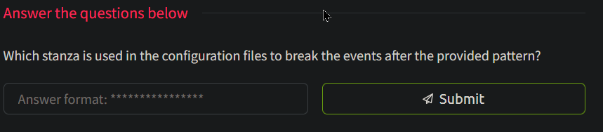

Answer: BREAK_ONLY_AFTER

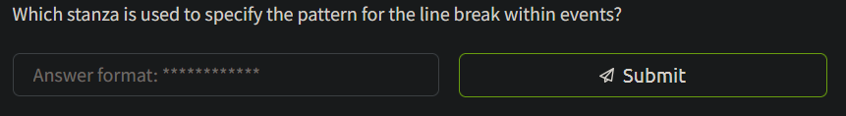

Answer: LINE_BREAKER

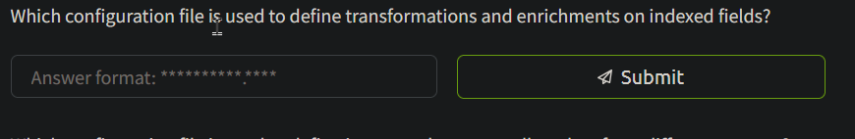

Answers: transforms.conf

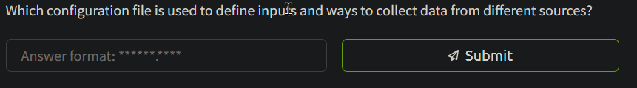

Asnwer: inputs.conf

Task 5

Creating a Simple Splunk App

We have explored the importance and usage of various configuration files and the purpose-based stanzas within those configuration files. We will be using them extensively in the coming tasks. For now, let’s create a simple Splunk app using the following steps and generate our first sample event using inputs.conf file.

**Start Splunk**

Splunk is installed in the /opt/splunk directory. Go to this directory and run the following command bin/splunk start to start the Splunk instance with root privileges. Use the following credentials to log in to the Splunk Interface:

**Username:** splunk

**Password:** splunk123

Once it is done, open 10.10.9.210:8000 in the browser.

About Splunk Apps  
Splunk apps are pre-packaged software modules or extensions that enhance the functionality of the Splunk platform. The purpose of Splunk apps is to provide specific sets of features, visualizations, and configurations tailored to meet the needs of various use cases and industries.

**Create a simple App**

Once the Splunk Instance is loaded, click on the Manage App tab as highlighted below:

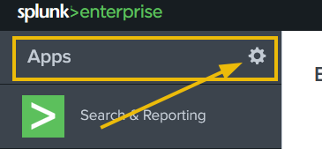

It will take us to the page that contains all the available apps in Splunk. To create a new app, Click on the Create App tab as shown below:

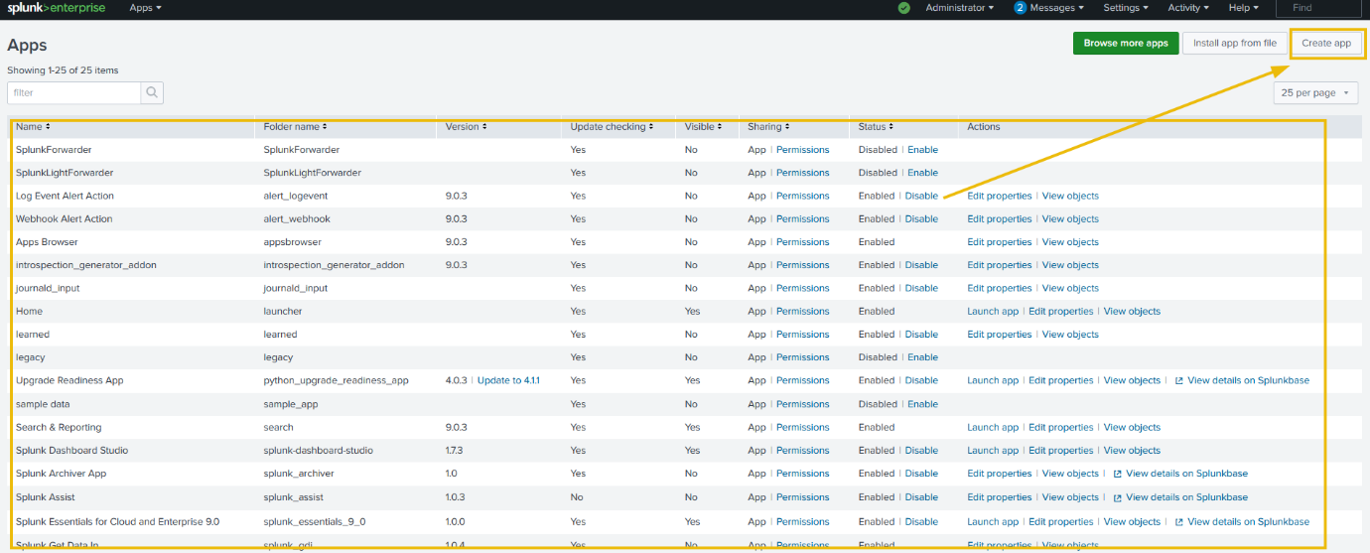

Next, fill in the details about the new app that we want to create. The new app will be placed in the /opt/splunk/etc/apps directory as highlighted below:

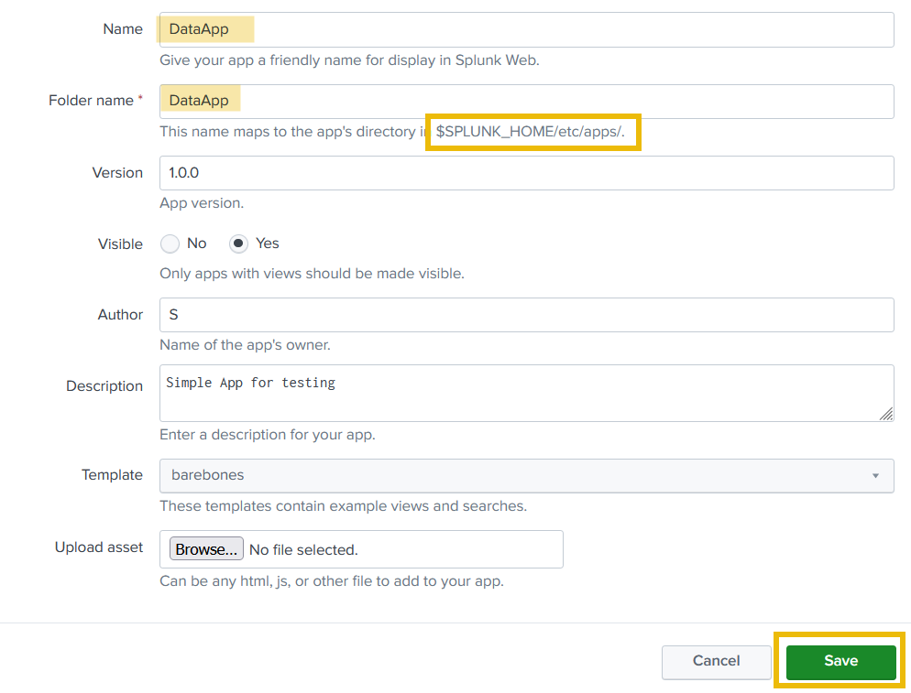

Great. A new Splunk app has been created successfully and it can be shown on the Apps page. Click on the Launch App to see if there is any activity logged yet.

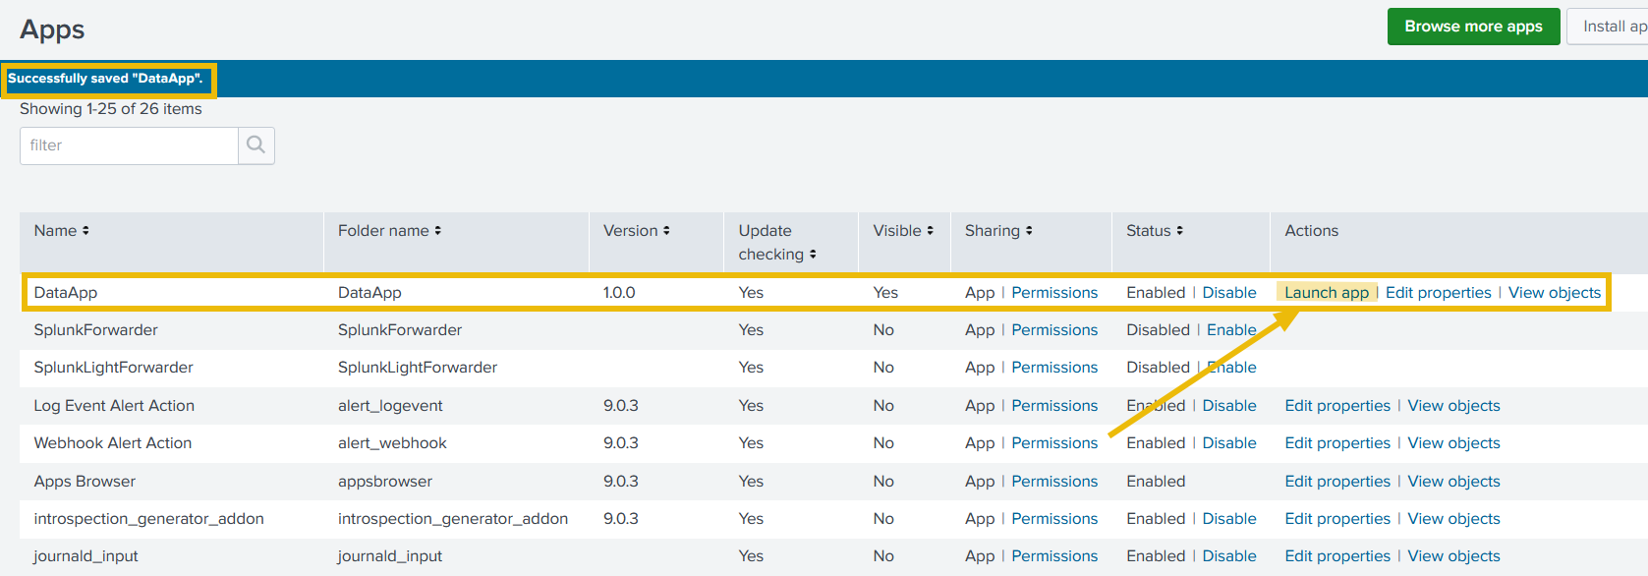

As it is evident, no activity has been logged yet. Follow the next steps to generate sample logs.

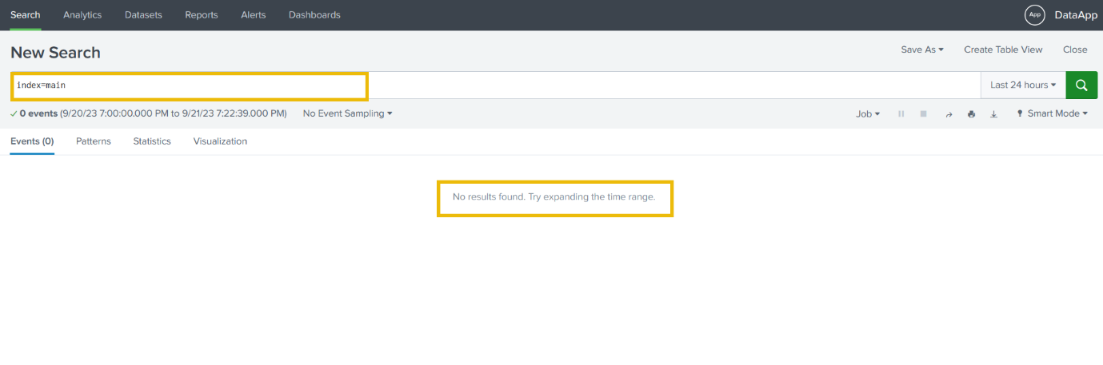

Understand the App directory

Go to the app directory /opt/splunk/etc/apps , where we can locate our newly created app DataApp, as shown below:

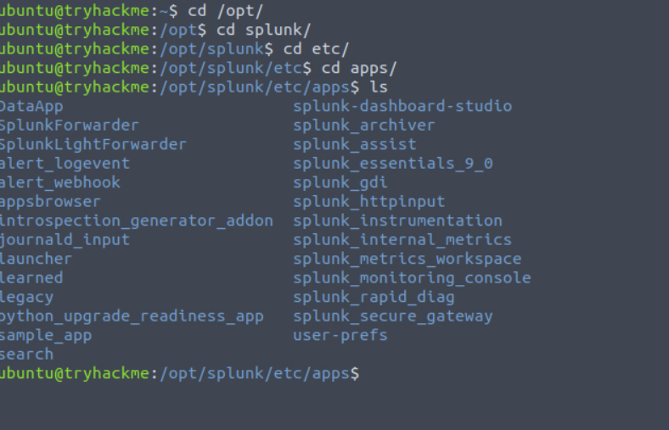ls

App Directory

root@tryhackme:/opt/splunk/etc/apps# ls

DataApp splunk-dashboard-studio

SplunkForwarder splunk_archiver

SplunkLightForwarder splunk_assist

alert_logevent splunk_essentials_9_0

alert_webhook splunk_gdi

appsbrowser splunk_httpinput

introspection_generator_addon splunk_instrumentation

journald_input splunk_internal_metrics

launcher splunk_metrics_workspace

learned splunk_monitoring_console

legacy splunk_rapid_diag

python_upgrade_readiness_app splunk_secure_gateway

sample_app user-prefs

search

Content within the App directory

App Directory

root@tryhackme:/opt/splunk/etc/apps# ls DataApp

bin default local metadata

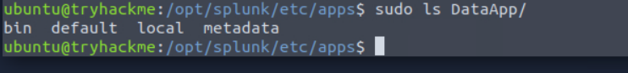

**Splunk App directory**

Some of the key directories and files that are present in the app directory are explained briefly below:

| **File/Directory** | **Description** |
| --- | --- |
| app.conf | Metadata file defining the app’s name, version, and more. |
| bin (directory) | Holds custom scripts or binaries required by the app. |
| default (directory) | Contains XML files defining app dashboards and views. |
| local (directory) | Optionally used for overriding default UI configurations. |
| c |  |

**Create a Python script to generate sample logs**

As we learned that the **bin** directory contains the scripts required by the app, let's go to the bin directory and create a simple Python script using the command nano samplelogs.py, copy the following line in the file, and save.

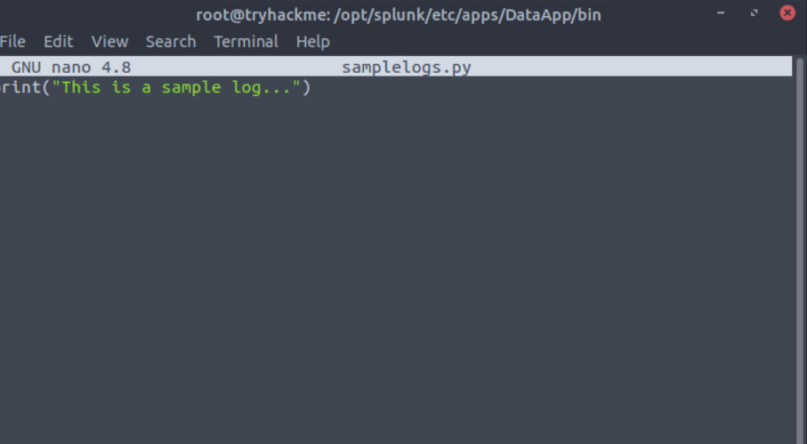

print("This is a sample log...")

Let’s use python3 to run the file as shown below and see what output we get:

python script

root@tryhackme:/opt/splunk/etc/apps/DataApp/bin# python3 samplelogs.py

This is a sample log...



It seems, the script is ready. Note down the full path of the script file, that is /opt/splunk/etc/apps/DataApp/bin/samplelogs.py, which we will need later.

**Creating Inputs.conf**

In the default directory, we will create all necessary configuration files like inputs.conf, transform.conf, etc. For now, let’s create an inputs.conf using the command nano inputs.conf add the following content into the file and save.

[script:///opt/splunk/etc/apps/DataApp/bin/samplelogs.py]

index = main

source = test_log

sourcetype = testing

interval = 5

The above configuration picks the output from the script samplelogs.py and sends it to Splunk with the index main every 5 seconds.

Restart Splunk using the command /opt/splunk/bin/splunk restart.

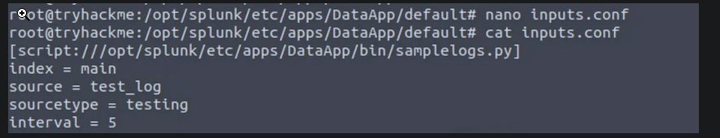



Summary

So far, we have created a simple Splunk app, used the bin directory to create a simple Python script, and then created inputs.conf file to pick the output of the script and throw the output into Splunk in the main index every 5 seconds. In the coming tasks, we will work on the scripts that will generate some events that will have visible parsing issues and then we will work with different configuration files to fix those parsing issues.

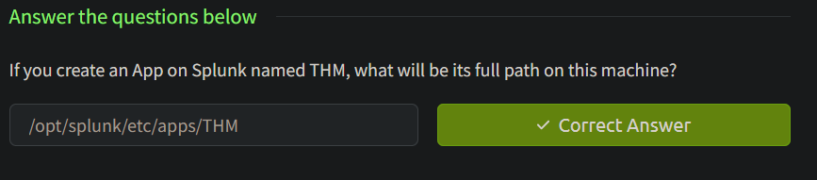

Task 6

Event Boundaries - Understanding the problem

Event breaking in Splunk refers to breaking raw data into individual events based on specified boundaries. Splunk uses event-breaking rules to identify where one event ends, and the next begins. Let’s walk through an example using a sample log to understand how event breaking works in Splunk.  
Understanding the Events  
In this room, we will be working on the DataApp created in the previous task and is placed at /opt/splunk/etc/apps/DataApp/.

For this task, we will use the Python script vpnlogs from the ~/Downloads/scripts directory, as shown below:

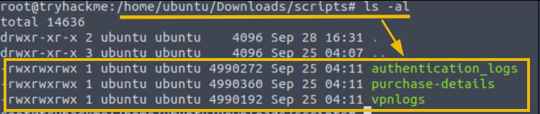

This directory contains various scripts, which we will explore later in this room. For now, let’s focus on the vpnlogs script.

Let’s say our client has a custom VPN application that generates VPN logs that contain information about the user, the VPN server, and the action performed on the connection, as shown in the output below when we run the command ./vpnlogs:

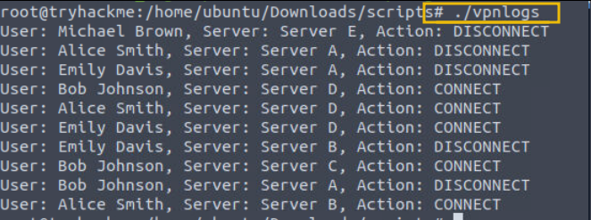

Generating Events

Our first task is to configure Splunk to ingest these VPN logs. Copy the vpnlogs script into the bin directory, open the inputs.conf , and write these lines:

[script:///opt/splunk/etc/apps/DataApp/bin/vpnlogs]

index = main

source = vpn

sourcetype = vpn_logs

interval = 5

The above lines tell Splunk to run the script vpnlogs every 5 seconds and send the output to the main index with sourcetype vpn_logs and host value as vpn_server. The inputs.conf file looks like this:

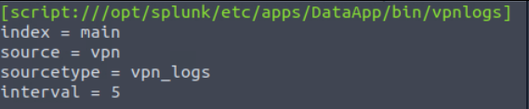

**Restart Splunk**

Save the file and restart Splunk using the command /opt/splunk/bin/splunk restart. Open the Splunk instance at 10.10.9.210:8000 and navigate to the search head.

**Search Head**

Select the time range  All time (Real-time) and use the following search query to see if we are getting the logs. **Search Query:** index=main sourcetype=vpn_logs

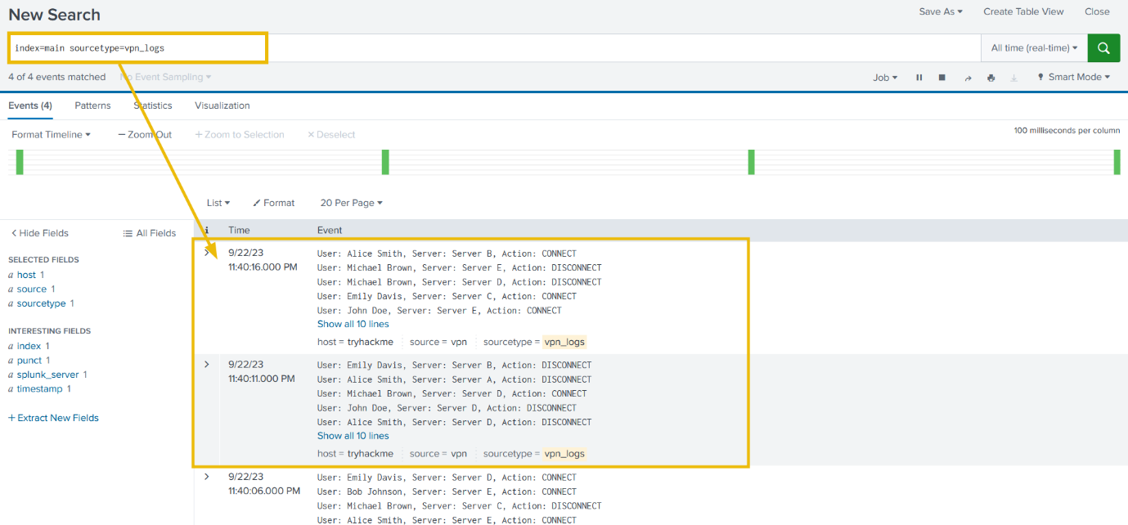

Identifying the problem  
Excellent, we are getting the VPN logs after every 5 seconds. But can you observe the problem? It's evident that Splunk cannot determine the boundaries of each event and considers multiple events as a single event. By default, Splunk breaks the event after carriage return.

**Fixing the Event Boundary**

We need to fix the event boundary. To configure Splunk to break the events in this case, we have to make some changes to the props.conf file. First, we will create a regex to determine the end of the event. The sample events are shown below:

**Sample Events**

User: Emily Davis, Server: Server C, Action: DISCONNECT

User: John Doe, Server: Server B, Action: DISCONNECT

User: Bob Johnson, Server: Server B, Action: DISCONNECT

User: Emily Davis, Server: Server D, Action: CONNECT

User: Alice Smith, Server: Server D, Action: CONNECT

User: Alice Smith, Server: Server A, Action: DISCONNECT

User: Bob Johnson, Server: Server C, Action: DISCONNECT

User: John Doe, Server: Server D, Action: DISCONNECT

User: John Doe, Server: Server B, Action: DISCONNECT

User: Michael Brown, Server: Server E, Action: CONNECT

We will use [reg101.com](https://tryhackme.com/r/room/reg101.com) to create a regex pattern. If we look closely, all events end with the terms DISCONNECT or CONNECT. We can use this information to create a regex pattern (DISCONNECT|CONNECT) , as shown below:

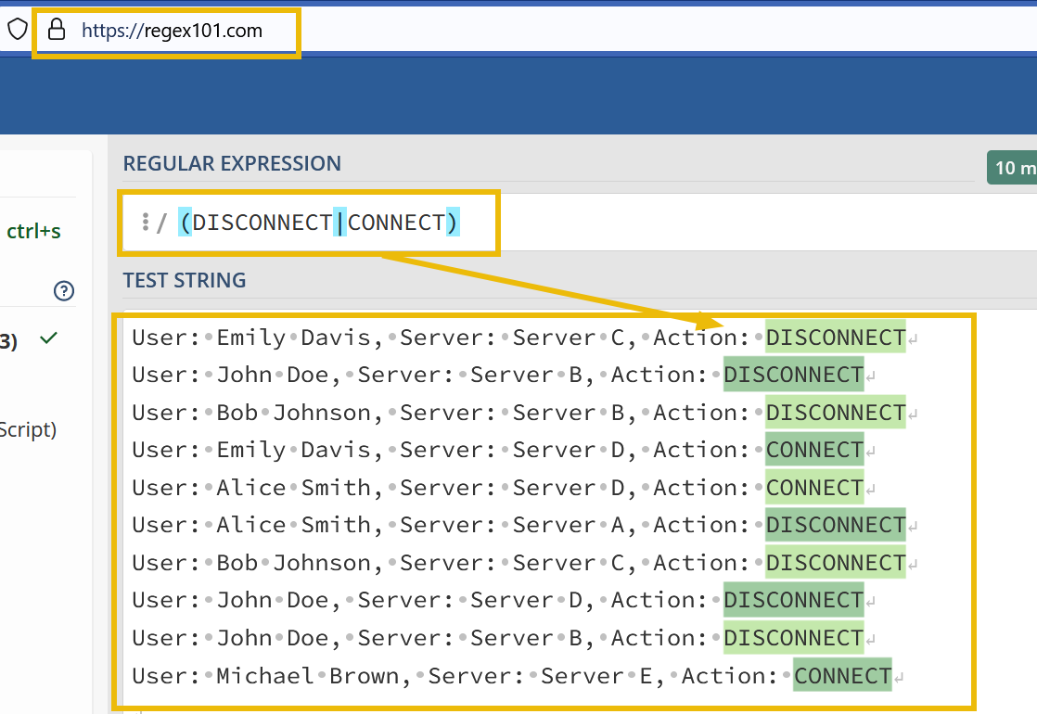

Now, let’s create a props.conf in the default directory within the DataApp and add the following lines:

[vpn_logs]

SHOULD_LINEMERGE = true

MUST_BREAK_AFTER = (DISCONNECT|CONNECT)

This configuration tells Splunk to take the sourcetype to merge all lines and it **must break** the events when you see the pattern matched in the mentioned regex.

**Restart Splunk**

Save the file and restart Splunk using the command /opt/bin/splunk restart. Open the Splunk instance at 10.10.9.210:8000 and navigate to the search head.



That’s it. We can see that with a few changes in the props.conf file, we changed how Splunk broke these VPN logs generated by the custom vpn_server.

In the next task, we will look at a different case study.

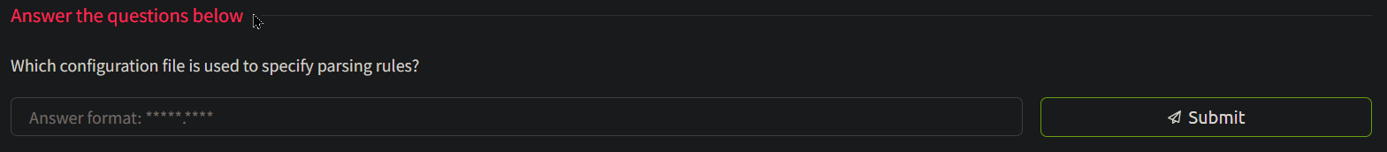

props.conf







Task 7

Parsing Muilt-line Events

As we know, different log sources have their own ways of generating logs. What if, a log source generates event logs that comprise of multi-lines? One such example is Windows Event logs. In order to understand how multi-line events can be handled in Splunk, we will use the event logs generated from the script authentication_logs. The sample event log is shown below:

[Authentication]:A login attempt was observed from the user Michael Brown and machine MAC_01

at: Mon Jul 17 08:10:12 2023 which belongs to the Custom department. The login attempt looks suspicious.

As it is clearly shown, the event contains multiple lines. Let’s update the inputs.conf file to include this script and see if Splunk is able to break the event as intended.

Copy the authentication_logs script from the ~/Downloads/scripts directory into the bin folder of the DataApp and add the following lines in inputs.conf, save the file, and restart Splunk:

[script:///opt/splunk/etc/apps/DataApp/bin/authentication_logs]

interval = 5

index = main

sourcetype= auth_logs

host = auth_server

**Search Head**

Let’s look at the Splunk Search head to see how these logs are reflected.

**Search Query**: index=main sourcetype = auth_logs

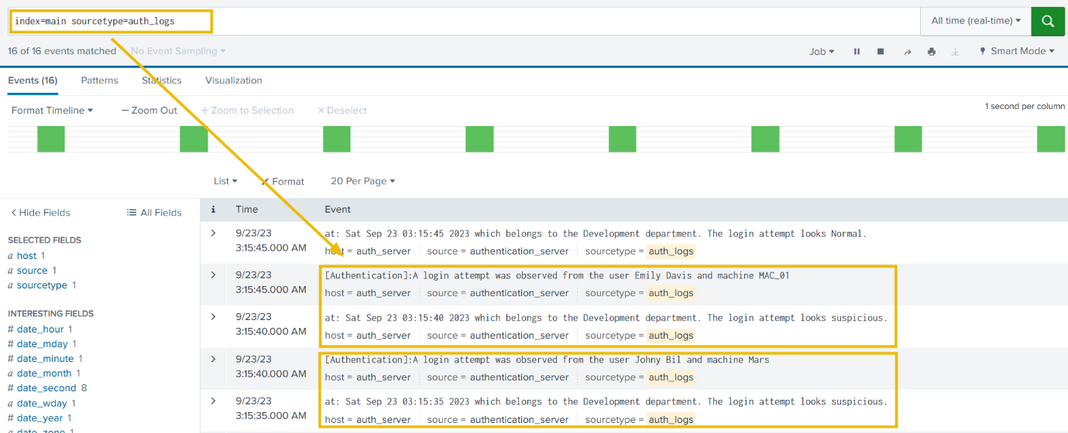

Identifying the problem

If we observe the events, we will see that Splunk is breaking the 2-line Event into 2 different events and is unable to determine the boundaries.

**Fixing the Event Boundary**

In order to fix this issue, we can use different stanzas in the props.conf file. If we run the script a few times to observe the output, we can see that each event starts with the term [Authentication], indicating the start of the event. We can use this as the regex pattern with the stanza BREAK_ONLY_BEFORE and see if it could fix this problem. Copy the following lines in props.conf file, save the file, and then restart Splunk to apply changes.

[auth_logs]

SHOULD_LINEMERGE = true

BREAK_ONLY_BEFORE = \[Authentication\]

**Search head**

Go to Splunk Search head, and use the following search query.

**Search Query**: index=main sourcetype = auth_logs



Great. See, now Splunk is able to break the event exactly how it was intended.

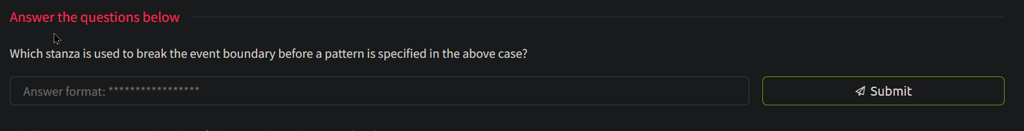

BREAK_ONLY_BEFORE



\[Authentication\]

Task 8

Masking Sensitive Data

Masking sensitive fields, such as credit card numbers, is essential for maintaining compliance with standards like PCI DSS (Payment Card Industry Data Security Standard) and HIPAA (Health Insurance Portability and Accountability Act). Splunk provides features like field masking and anonymization to protect sensitive data. Here’s an example of credit card numbers being populated in the Event logs generated by the script purchase-details present in the ~/Downloads/scripts directory.

Sample Output

User William made a purchase with credit card 3714-4963-5398-4313.

User John Boy made a purchase with credit card 3530-1113-3330-0000.

User Alice Johnson made a purchase with credit card 6011-1234-5678-9012.

User David made a purchase with credit card 3530-1113-3330-0000.

User Bob Williams made a purchase with credit card 9876-5432-1098-7654.

Copy this script file into the bin folder of the DataApp and configure the inputs.conf file to ingest these logs into Splunk. To do so, add the following lines in the inputs.conf file.

[script:///opt/splunk/etc/apps/DataApp/bin/purchase-details]

interval = 5

index = main

source = purchase_logs

sourcetype= purchase_logs

host = order_server

This configuration tells Splunk to get the output from the purchase-details script, and index into the main index every 5 seconds, with sourcetype  purchase_logs and host as order_server. Now, save the file and restart Splunk. Log on to Splunk and apply the following search query: **Search Query**: index=main sourcetype=purchase_logs

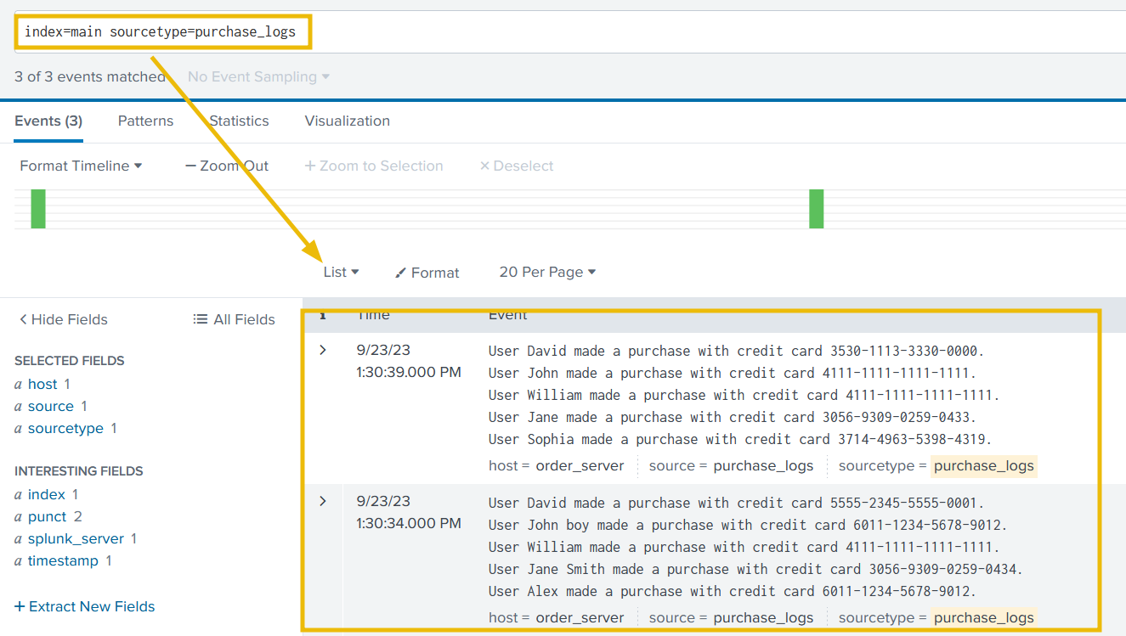

It looks like we have two problems to address. We need to hide the credit card information that is being added to each event and also need to fix the event boundaries.

**Fixing Event Boundaries**

We will use regex101.com to create a regex pattern to identify the end boundary of each event, as shown below:

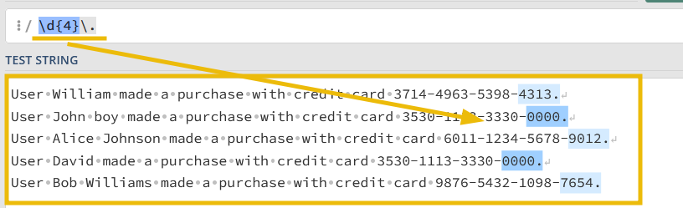

Let’s update the props.conf, as shown below:

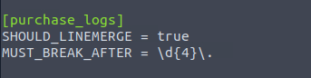

Save the file, and restart Splunk. If everything goes well, the event should be propagating correctly, as shown below:

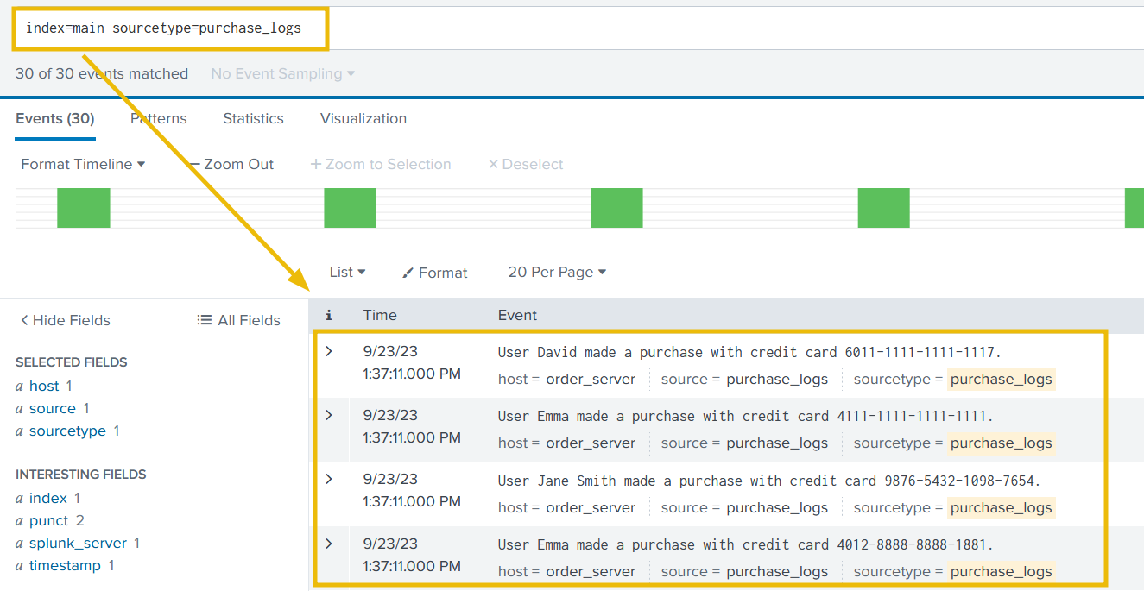

Now that we have fixed the event boundary issue. It’s time to mask the sensitive information from the events.

Introducing SEDCMD

In Splunk, the sedcmd configuration setting is used in the props.conf file to modify or transform data during indexing. It allows us to apply regular expression-based substitutions on the incoming data before indexing it. The sedcmd setting uses the syntax and functionality of the Unix sed command.

Here’s a brief explanation of how the sedcmd works in props.conf:

1. Open the props.conf file in your Splunk configuration directory.
2. Locate or create a stanza for the data source you want to modify.
3. Add the sedcmd setting under the stanza.
4. Specify the regular expression pattern and the replacement string using the s/ syntax similar to the sed command.

Here’s an example of using sedcmd in props.conf to modify a field called myField:

[source::/path/to/your/data]

SEDCMD-myField = s/oldValue/newValue/g

In this example, the sedcmd setting is applied to the data from a specific source path. It uses the regular expression pattern oldValue and replaces it globally with newValue using the g flag in the myField field. This transformation occurs before Splunk indexes the data.

It is important to note that, this sedcmd is just one of the configuration settings props.conf used for data transformation. There are other options available, such as REGEX, TRANSFORMS, etc.

Masking CC Information

Let’s now use the above knowledge gain to create a regex that replaces the credit card number with something like this -> 6011-XXXX-XXXX-XXXX., as shown below:

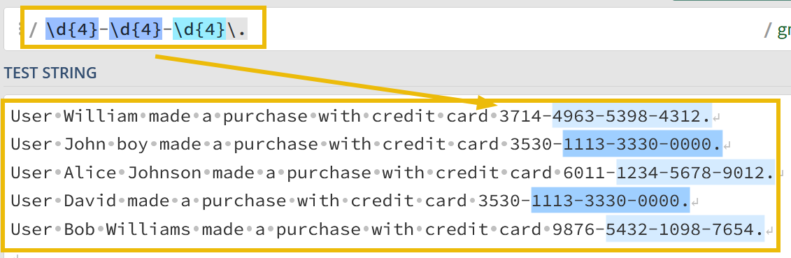

Now, our task is to use this s/OLD_VALUE>/<NEW_VALUE>/g regex in sedcmd to replace the credit card numbers with XXXX-XXXX-XXXX. The final sedcmd value will become s/-\d{4}-\d{4}-\d{4}/-XXXX-XXXX-XXXX/g

Our configuration in the props.conf would look like this:

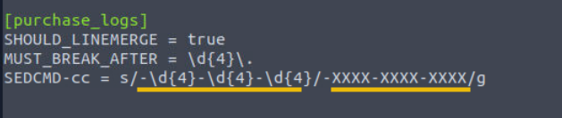

Restart Splunk and check Splunk Instance to see how our changes are reflected in the logs.



Great. With some changes in the configurations, we were able to mask the sensitive information. As a SOC analyst, it is important to understand the criticality of masking sensitive information before being logged in order to comply with standards like HIPAA, PCI-DSS, etc.

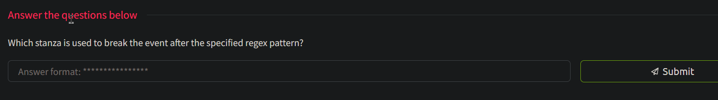

MUST_BREAK_AFTER



s/oldValue/newValue/g

Task 9

Extracting Custom Fields

From a SOC analyst’s point of view, we would often encounter logs either custom log sources, where not all fields are extracted by the SIEM automatically, or we are required to extract custom fields to improve the analysis. In that case, we need a way to extract custom fields from the logs. To demonstrate this with an example, let’s go back to our vpn_logs case. The output we are getting in Splunk is, as shown below:

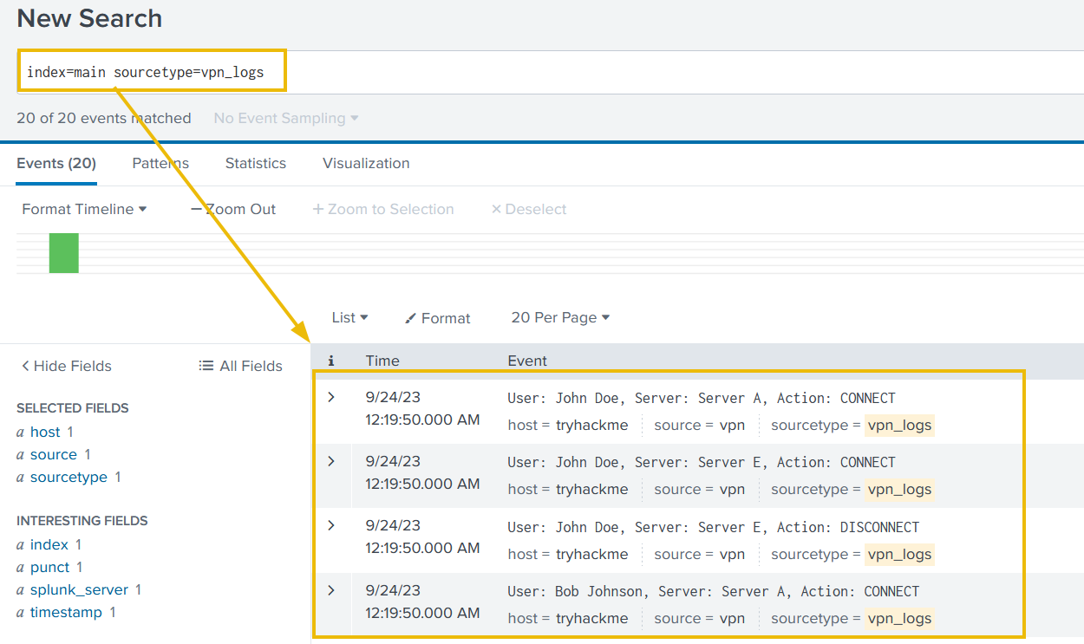

It's clear that none of the fields are extracted automatically, and we can not perform any analysis on these events until fields like **username**, **server**, and **action** are extracted.

**Extracting Username**

Let’s first go through the process of extracting the usernames and putting them under the field as **Username**, and then we can follow the same steps to extract other fields as well.

**Creating Regex Pattern**

Our first task would be to create a regex pattern to capture the username values we are trying to capture. Sample event logs look like this:

User: John Doe, Server: Server C, Action: CONNECT

User: John Doe, Server: Server A, Action: DISCONNECT

User: Emily Davis, Server: Server E, Action: CONNECT

User: Emily Davis, Server: Server D, Action: DISCONNECT

User: Michael Brown, Server: Server A, Action: CONNECT

User: Alice Smith, Server: Server C, Action: CONNECT

User: Emily Davis, Server: Server C, Action: DISCONNECT

User: John Doe, Server: Server C, Action: CONNECT

User: Michael Brown, Server: Server A, Action: DISCONNECT

User: John Doe, Server: Server D, Action: DISCONNECT

By creating a regex pattern as: User:\s([\w\s]+) and creating a capturing group, we have successfully captured all the usernames that we want to extract.

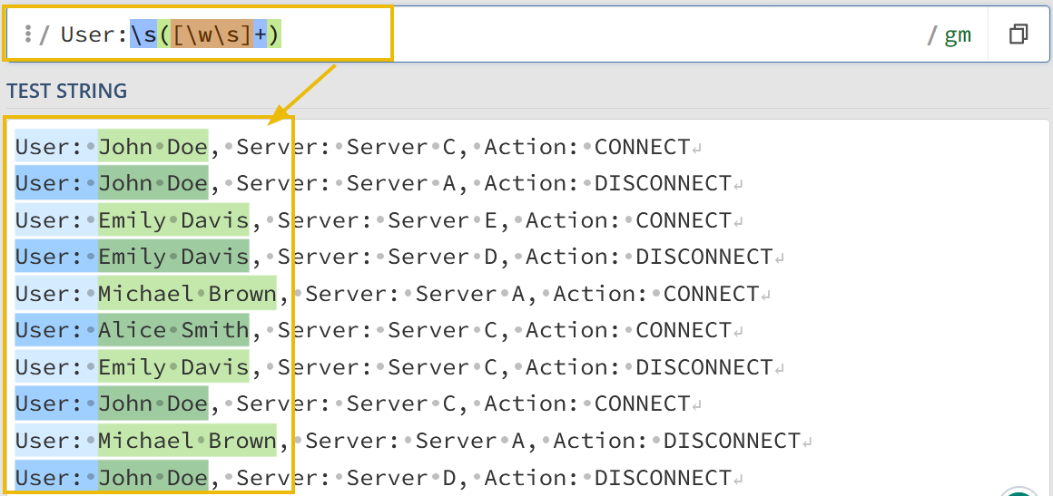

Creating and Updating transforms.conf

Now, let’s create a transforms.conf in the default folder of the DataApp directory, and put the following configurations in it as it is.

[vpn_custom_fields]

REGEX = User:\s([\w\s]+)

FORMAT = Username::$1

WRITE_META = true

The transforms.conf would look like this:

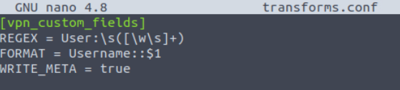

**Explanation:** We have created a custom identifier vpn_custom_fields, used the regex pattern to pull the usernames from the logs, mentioned the field name as Username, and asked to capture the first group by referring to it as $1. Save the configuration and move to the next step.

Updating props.conf

We need to update the props.conf to mention the recent updates we did in transforms.conf. Here, we are appending the configuration for sourcetype **vpn_logs** with the line TRANSFORM-vpn = vpn_custom_fields, as shown below:

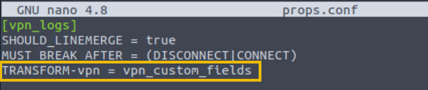

Creating and Updating fields.conf

The next step would be to create fields.conf and mention the field we are going to extract from the logs, which is Username. INDEXED = true means we are telling Splunk to extract this field at the indexed time.

[Username]

INDEXED = true

Fields.conf file would look like this:

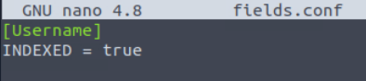

**Restart Splunk**

That’s all we need in order to extract the custom fields. Now, restart the Splunk instance so that the changes we have made are committed. Go to the Splunk instance and use the search query index=main sourcetype=vpn_logs



This is it. With some changes to the configuration files, we were able to extract a custom field from the logs.

Let's use the same process and extract the remaining two fields as well.

Creating Regex Pattern

This regex pattern User:\s([\w\s]+),.+(Server.+),.+:\s(\w+) captures all the three fields and places them into the groups, as shown below:

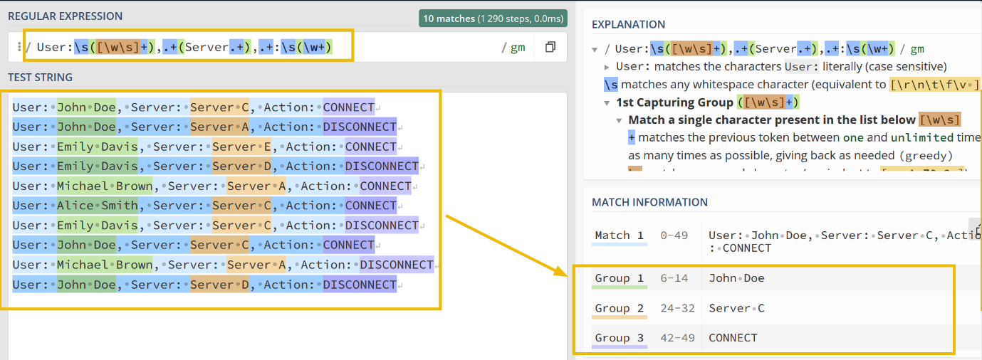

Updating transforms.conf

Now that we have captured the fields that we want to extract, let's update the transforms.conf file, as shown below:

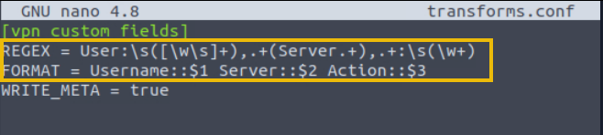

In the configuration file, we have updated the **REGEX** pattern and the **FORMAT**, where we have specified different fields separating with a space.

Updating fields.conf

Now it's time to update the fields.conf with the field names that we want Splunk to extract at index time.

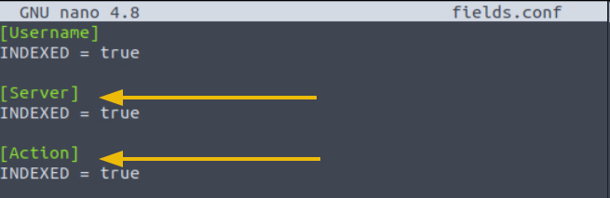

Restart Splunk

As we have updated the configuration, we will need to restart Splunk for the changes to work. After restarting, go to the Splunk instance and use the search query index=main sourcetype=vpn_logs  to check the impact of the changes we made earlier.



Answer the questions below

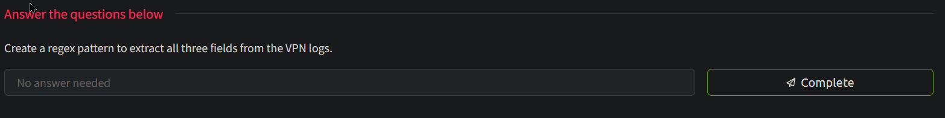



14

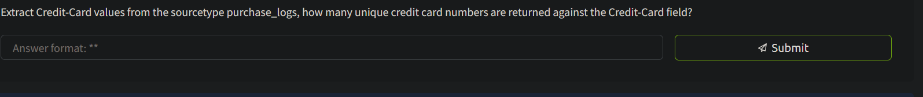

16

Task 10

Recap and Conclusion

This room covered how to configure Splunk to parse and manipulate data according to the situation or requirement. As a SOC Analyst, it's important to know how to change different configuration files to make Splunk work as intended. In this room, we learned the following:

* How to define Event boundaries in Splunk.
* How to mask Sensitive information.
* How to make configuration changes in inputs.conf, props.conf, and transforms.conf
* How to extract custom Events in Splunk.

In the next room, we will take more advanced topics in data manipulation in Splunk. To learn more about using Splunk to enhance your organization's security posture, check out the rest of the rooms in this module. Let us know what you found interesting in this room on our [Discord channel](https://discord.gg/tryhackme) or [Twitter account](http://twitter.com/realtryhackme).